MINT COOKIES  CLASSIC COOKIES | BY SIGNING BELOW, I HEREBY AGREE  that I will pay to Girl Guides of Canada – ___________________________________  the amount of $72.00 for each case of cookies I take from the unit. This amount will be paid by me as soon as possible and no later than ___________________, 2023.
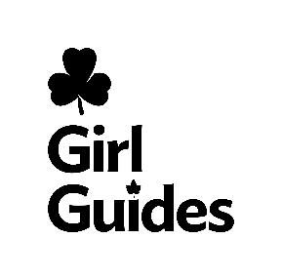
Date | Girl's Name | Parent Signature | Number of cases | Amount DUE | Date paid | Amount PAID | /cash /cheque / online | Date of deposit

